**Assignment No:-16**

Name:-Suryawanshi Sangramsingh Sambhaji

Batch: - Delta - DCA (Java) 2024 Date:-23/5/2024

**1. Write a java program to merge two Array and print the final array.**

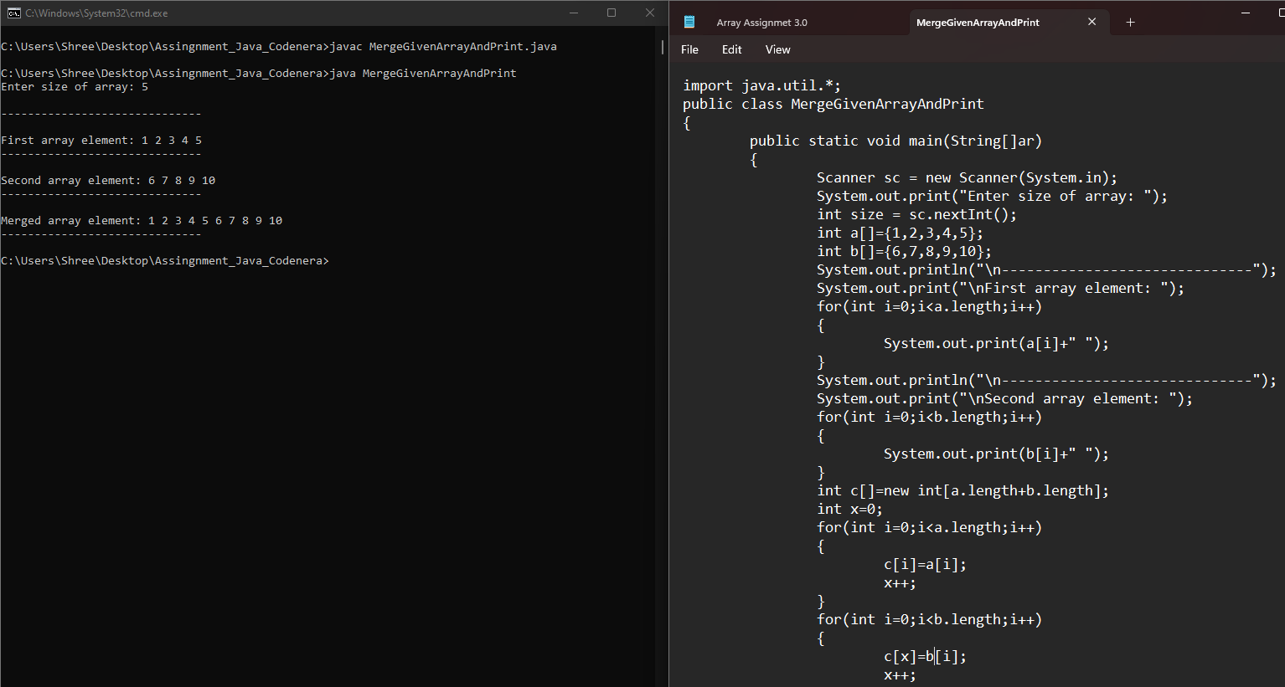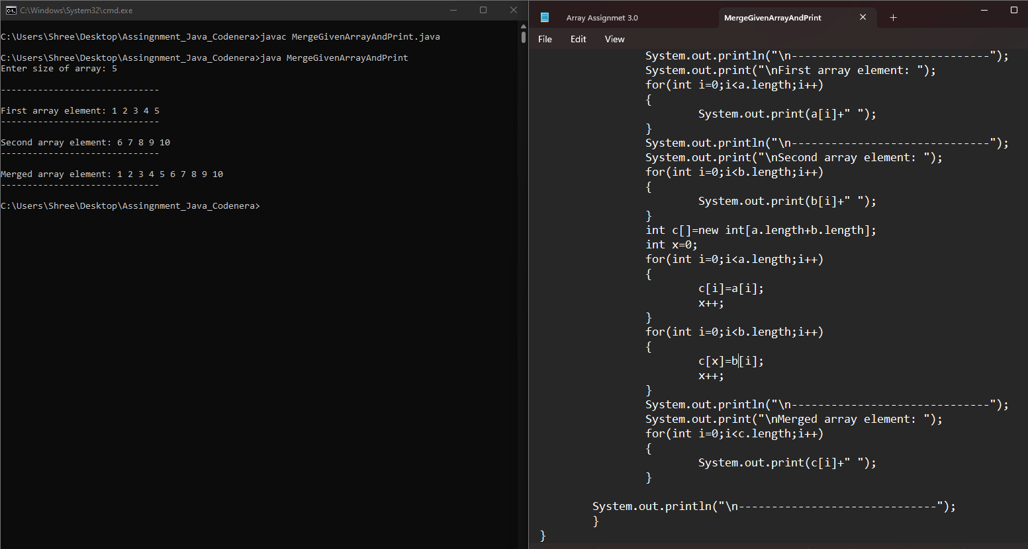

**2. Write a java program enter an array and sort that in ascending order.**

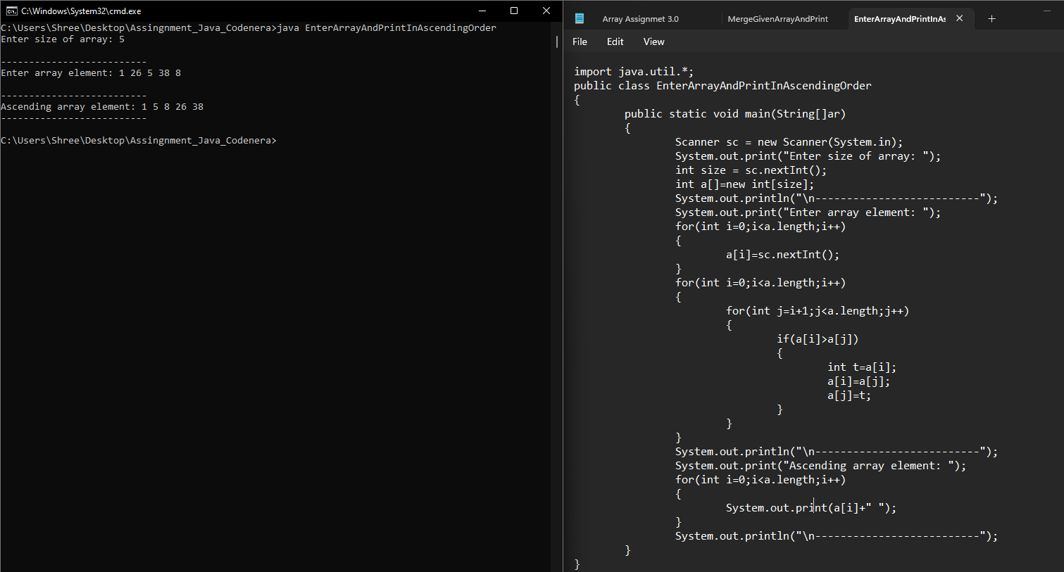

**3.** **Write a java program enter an array and sort that in descending order.**

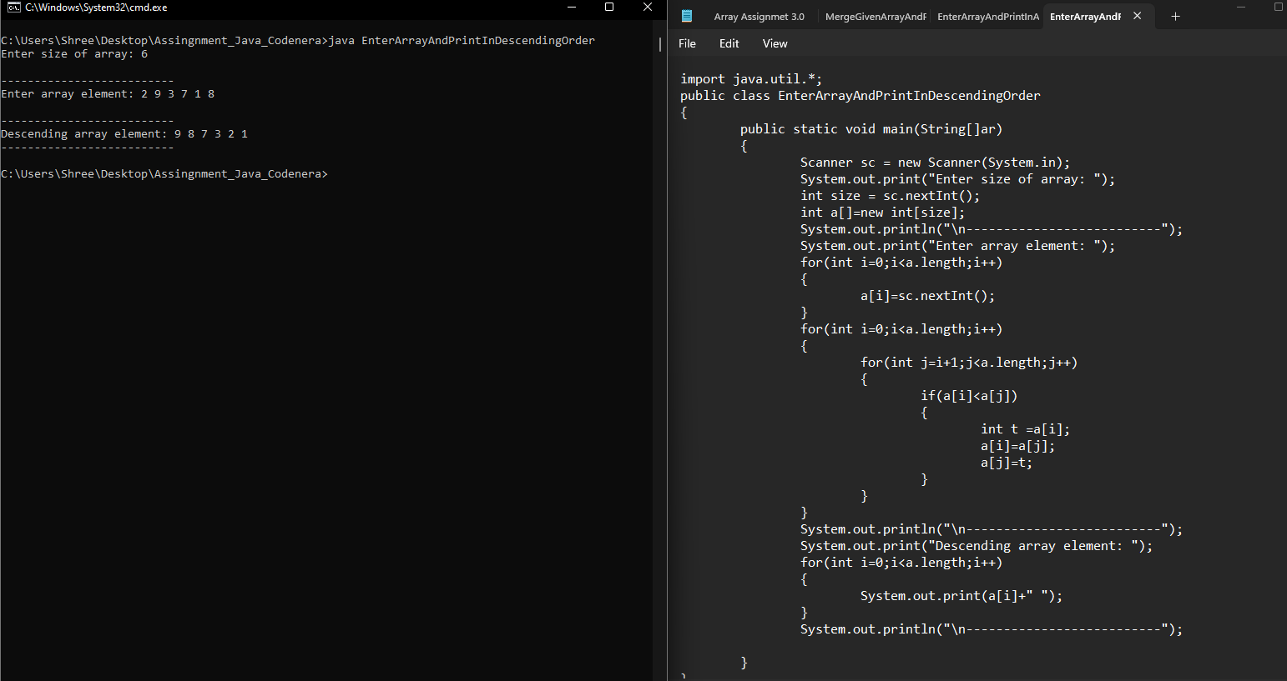

**4.** **Write a java program enter an array and find the second max element.**

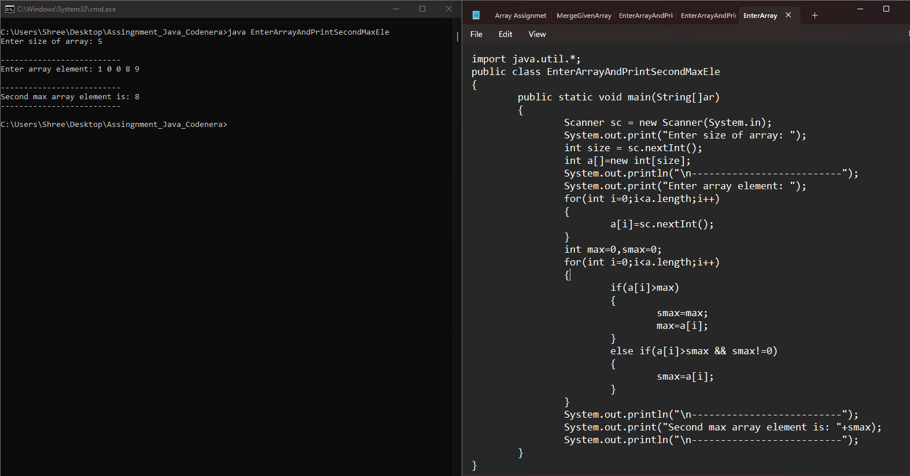

**5. Write a program enter an array and find the second min element.**

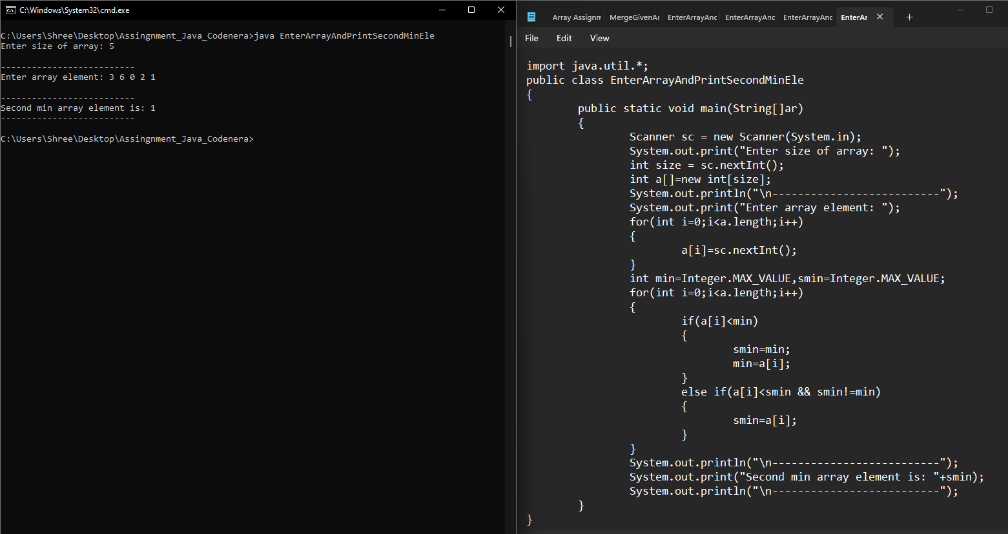

**6. Write a program enter an array and find max and min element.**

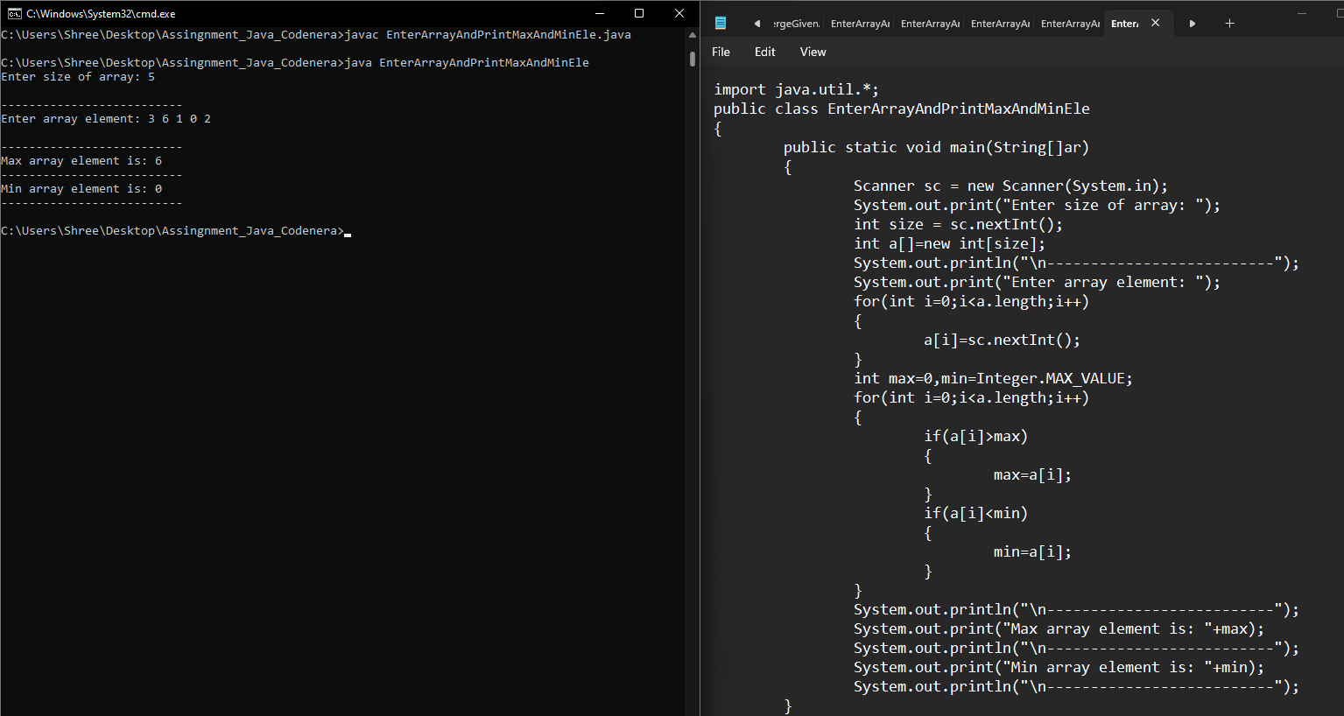

**7.** **Write a program Input 10 elements in float and print it.**

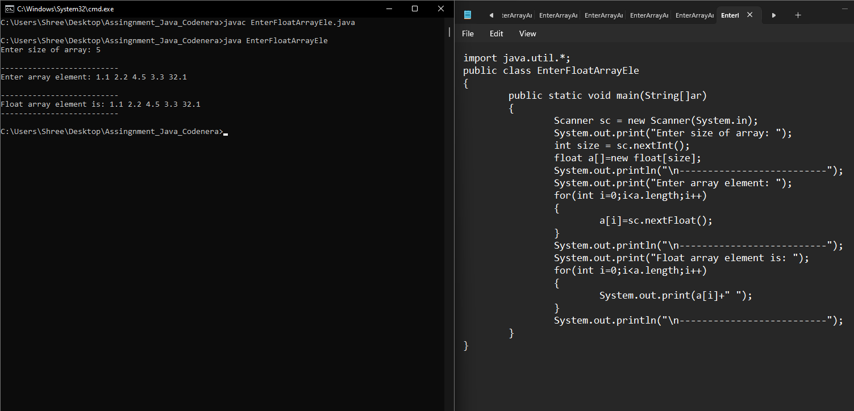

**8. Write a program input 10 name and print with index**

**Index name.**

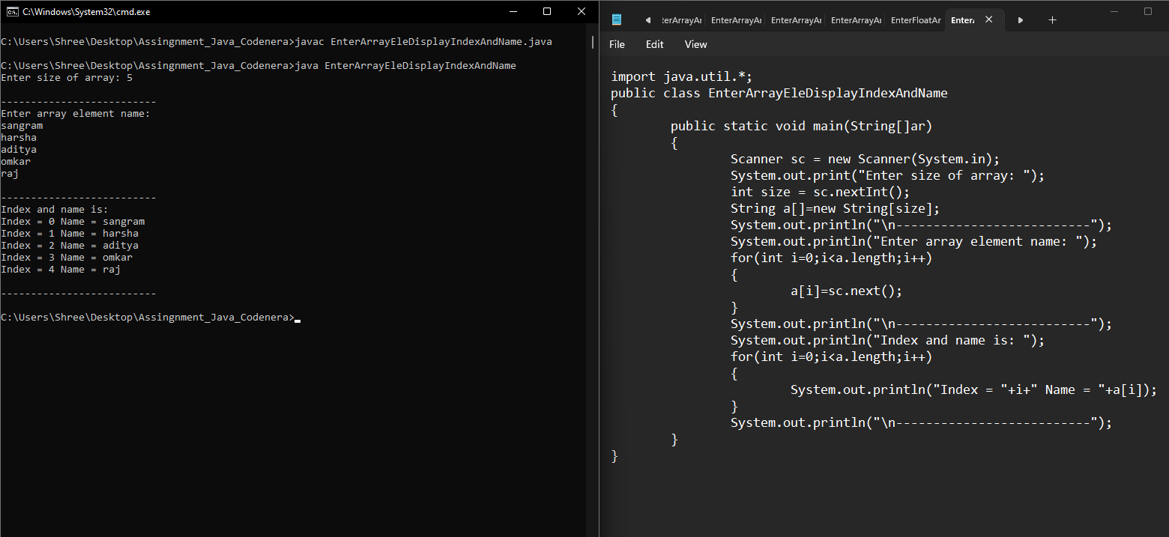

**9. Write a program to input an array and print it.**

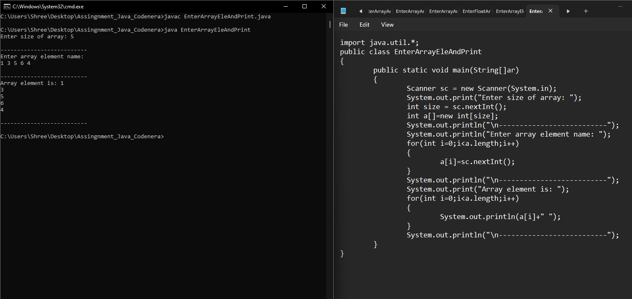

**10. Write a program initialise an array and print it.**

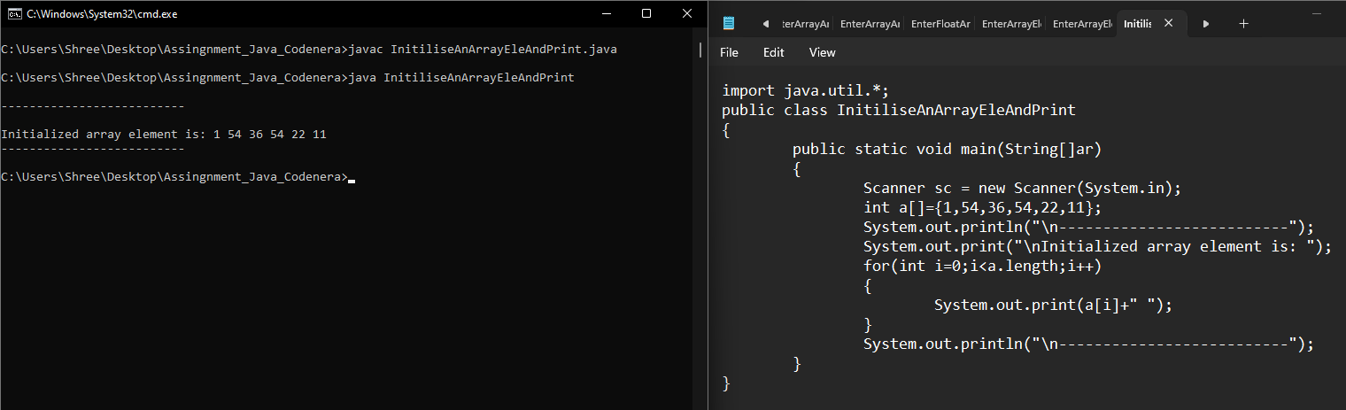

**11. Write a program input 10 elements and multiply 5th elements by 25.**

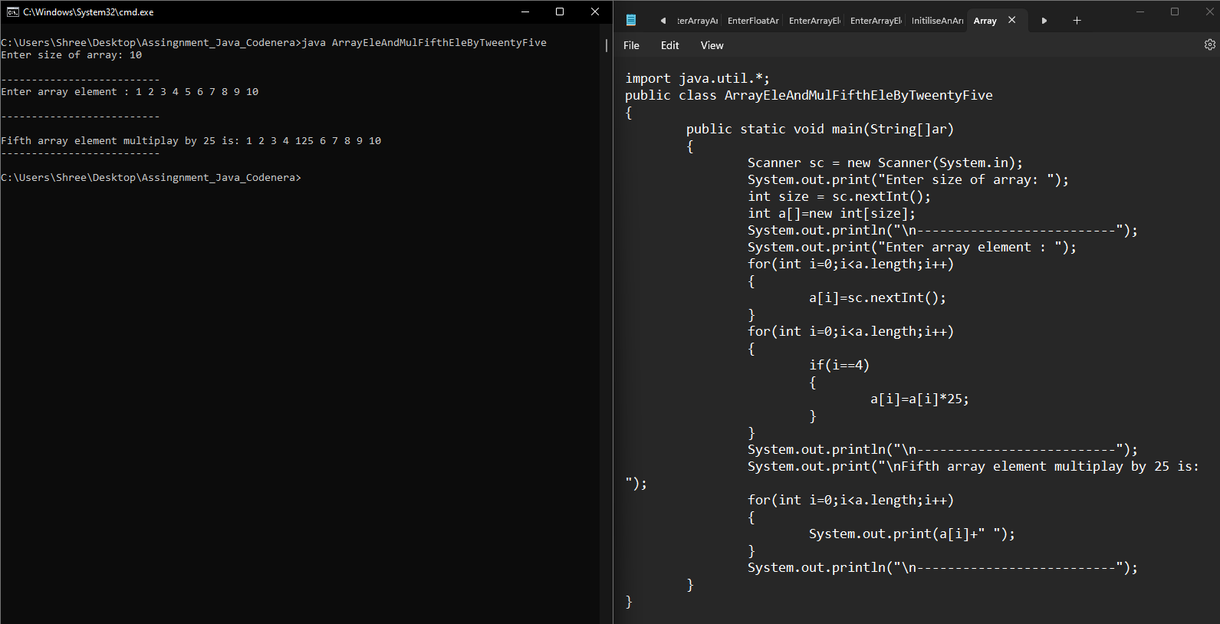

**12. Write a program to input an array and find its average of first 5 element.**

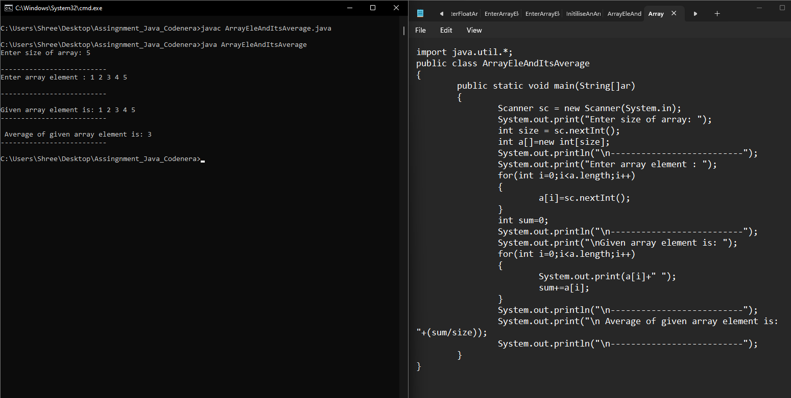

**13. Write a program enter an array and print the square of the element which is present at odd position.**

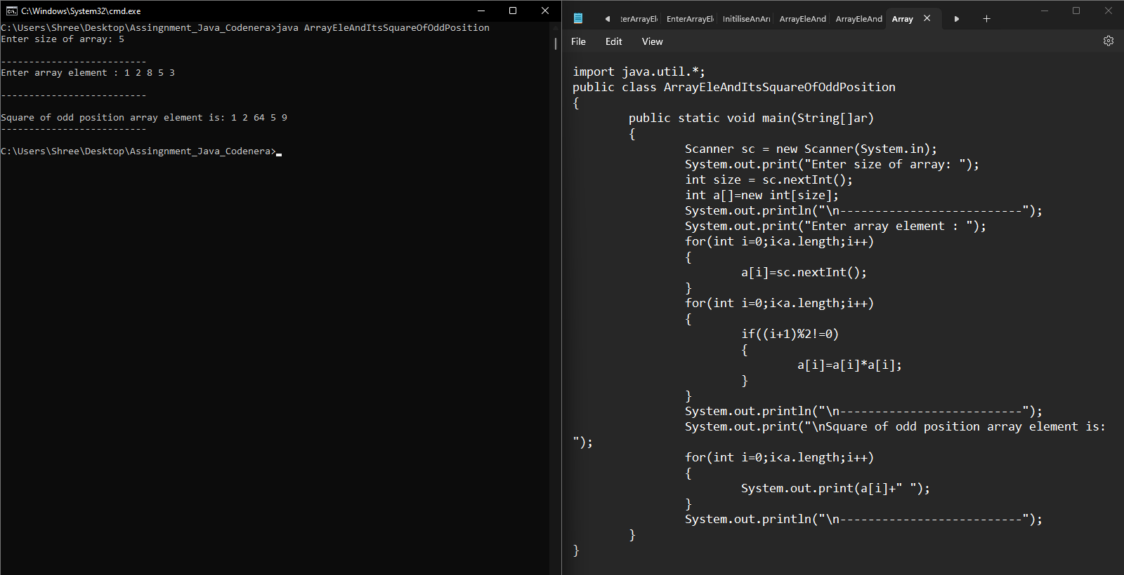

**14. Write a program enter an array and print the square of the element which is present at even position.**

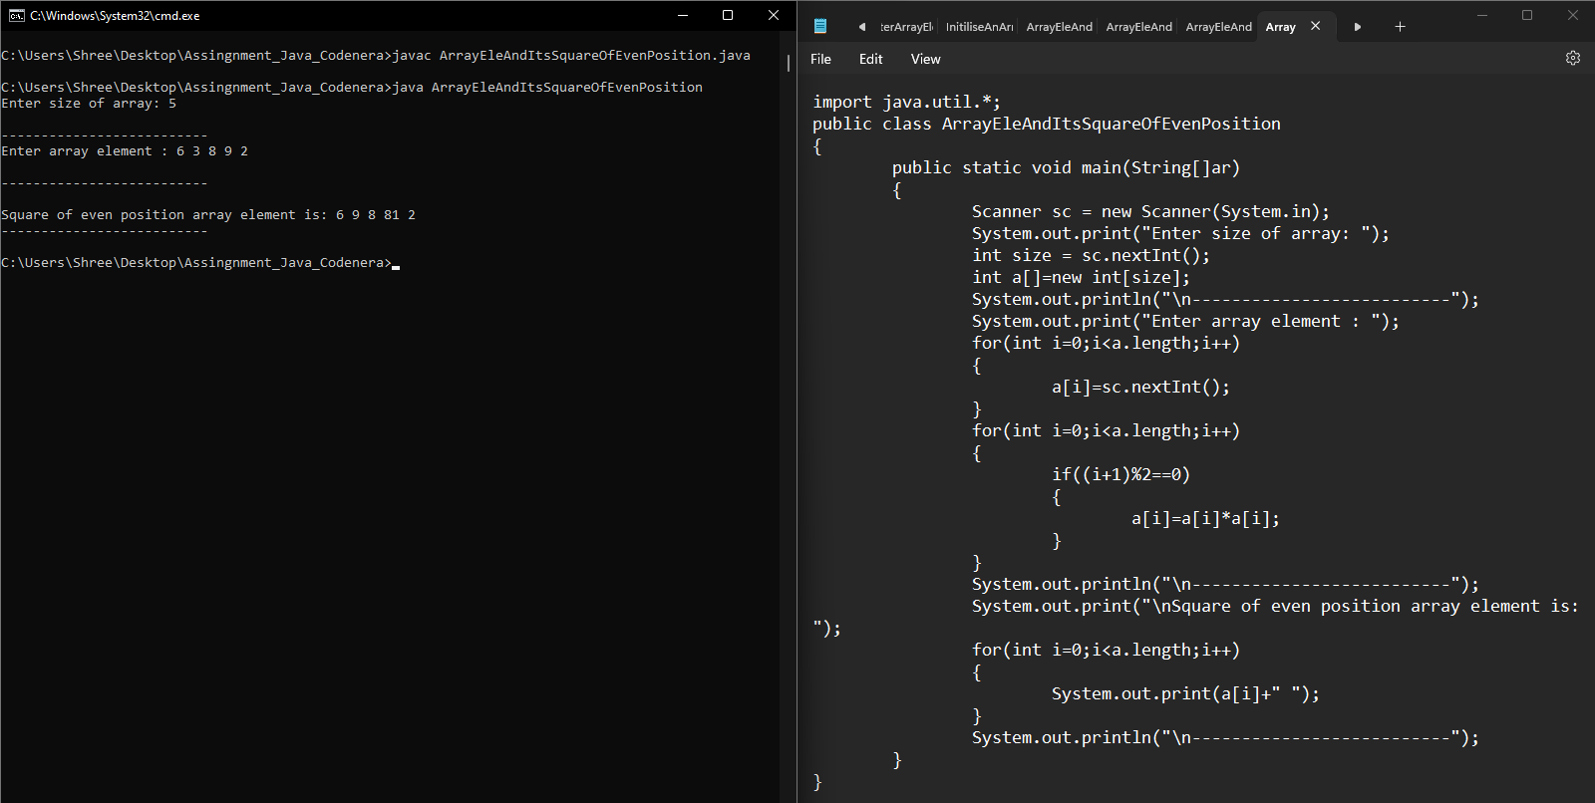

**15. Write a program input two array and merge in third array.**

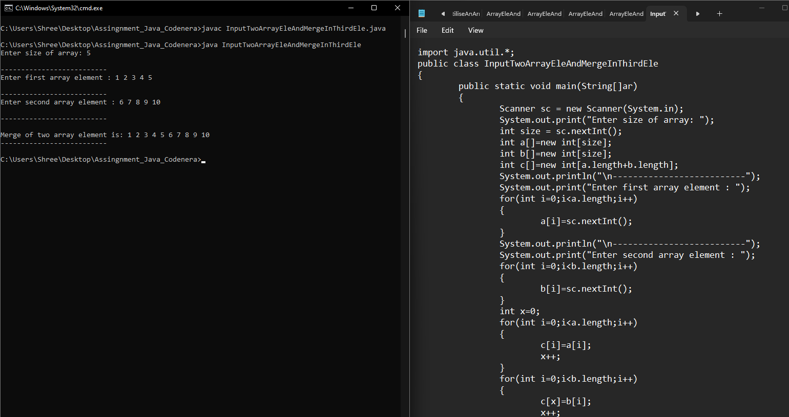

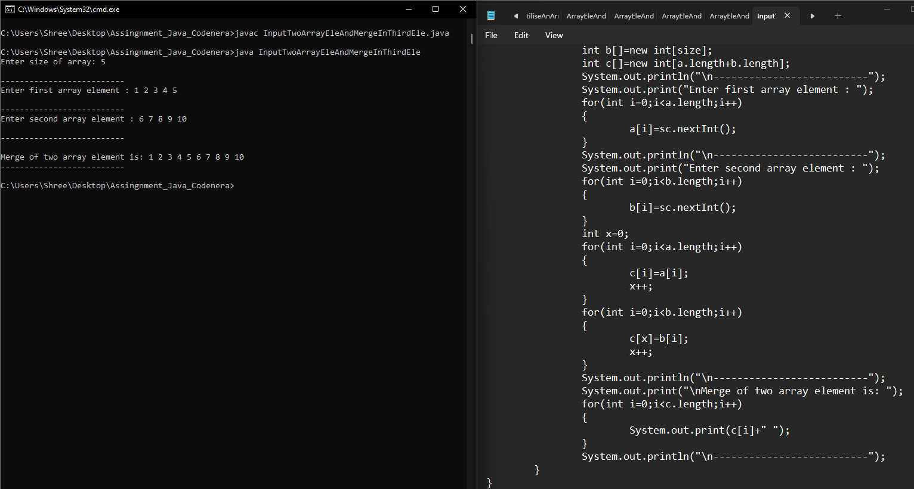

**16. Write a program a[]={10,20,30,40,50},b[]={1,2,3,4,5}**

**output array=c[]={10,5,20,4,30,3,40,2,50,1}.**

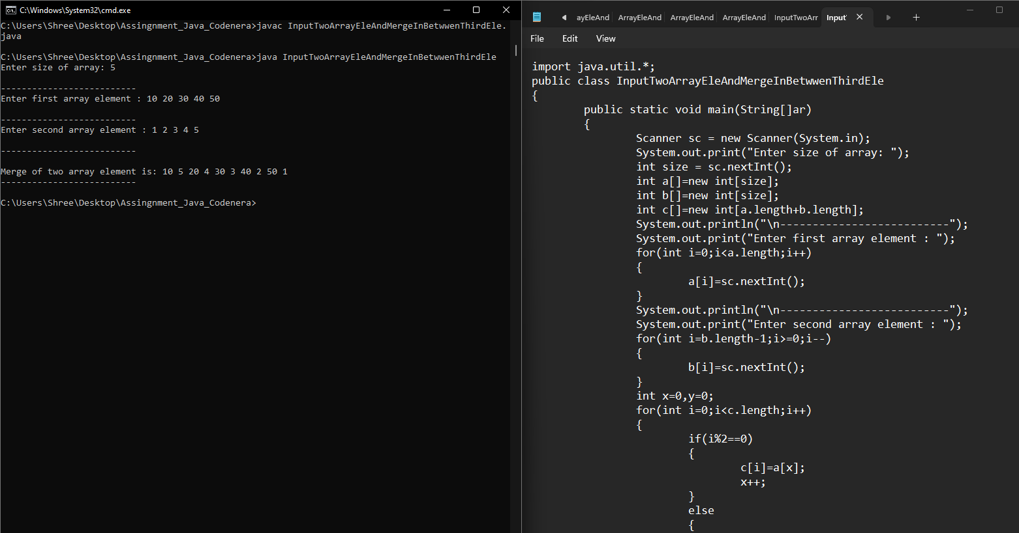

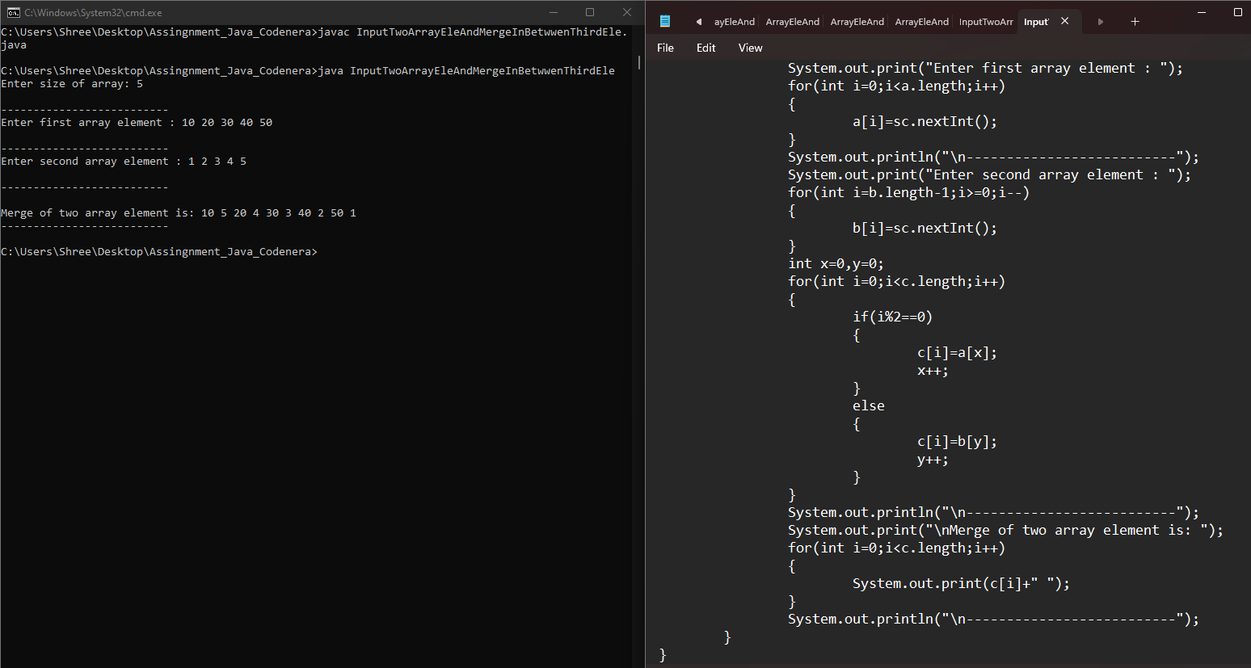

**17. Write a program sort half array in ascending and half in descending order**

**input= int [] a={9,1,3,5,6,11,22,66,10,19}.**

**output={1,3,5,6,9,10,66,22,19,11,10}**

**.** 